10-Day Gorillas, Chimps & the Big '5'

Embark on a 10-day adventure across Uganda, exploring stunning landscapes and diverse wildlife. Experience the thrill of encountering Mountain Gorillas in Bwindi Impenetrable National Park and observe Uganda's Big 5—Elephants, Lions, Leopards, Buffaloes, and Rhinoceros. This safari offers an unforgettable blend of nature and adventure.
ROUTE
Uganda
Start | Entebbe (Day 1)
Day 2-3 | Murchison Falls NP
Day 4-5 | Kibale NP (Chimps)
Day 6-7 | Queen Elizabeth NP
Day 8-9 | Bwindi Impenetrable NP (Gorillas)
End | Entebbe (City) (Day 10)

Tour Features

Mid-range tour
This mid-range tour uses lodges and resorts.

Private tour
This tour will be organized exclusively for you and won't be shared with others.

Can start any day
If availability permits, this tour can start on any day.

Can be customized
You can request minor changes to the accommodations and destinations of this tour.

Suitable for solo travelers
Solo travelers can book this private tour.

Minimum age of 18 years
The minimum age for this tour is 18 years.

Activities & Transportation

Activities:
- game drives, evening/night game drives,
- gorilla trekking.
- Chimpanzee trekking.
- Nature hikes/walks & boat trip
Game drives: pop-up roof 4x4 vehicle
Getting around: pop-up roof 4x4 vehicle
A transfer from and back to the airport is included

Accommodation & Meals
- Additional accommodation before and at the end of the tour can be arranged for an extra cost
- Day 1
Accommodation
Meals

Victoria View Boutique Hotel Mid-range hotel in Entebbe (City)

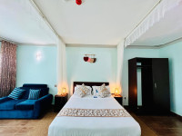
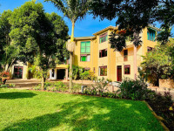
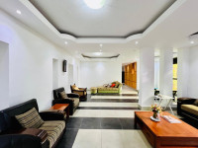

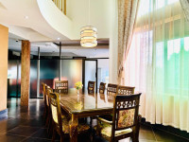

Dinner Included
- Day 2-3
Pakuba Safari Lodge Mid-range lodge inside Murchison Falls NP

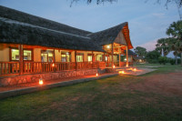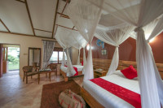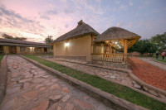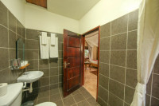
All Meals Included
- Day 4-5
Turaco Treetops Lodge Mid-range lodge bordering Kibale NP (Chimps) without fences

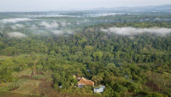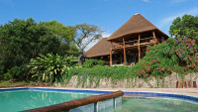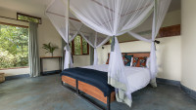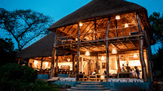
Photos

All Meals Included
- Day 6-7
Irungu Forest Safari Lodge Mid-range lodge just outside Queen Elizabeth NP

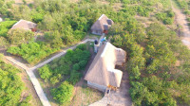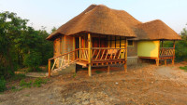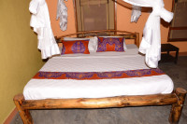

All Meals Included

- Day 8
Bakiga Lodge Budget lodge just outside Bwindi Impenetrable NP (Gorillas)

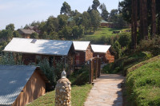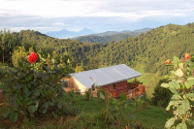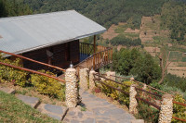

All Meals Included
- Day 9
Bunyonyi Safaris ResortMid-range resort at Lake Bunyonyi

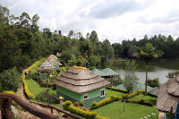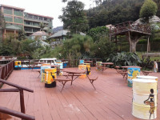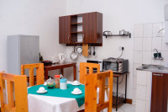
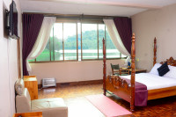

+6Photos

All Meals Included
- Day 10
End of tour
(No accommodation)
Breakfast & Lunch Included

Day by Day

Arrival

You'll be collected from the airport.
- Accommodation before the tour starts can be arranged for an extra cost.
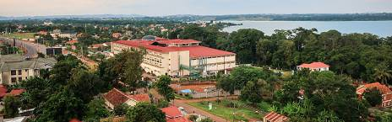

Day 1

Arrival
Arrive in Uganda following the Flight from your respective Country f Origin, you land at Entebbe International Airport which is the main gateway to Uganda where you will find a representative of your booked hotel and will offer you a courteous welcome.
The amazing weather, brightening atmosphere on the shores of Lake Victoria and the greenery give
you a remarkable first impression f Uganda. Connect to the respective hotel for overnight stay.
Main Destination:
Entebbe (City)
Accommodation:
Victoria View Boutique Hotel
- Mid-range hotel located in Entebbe (City)



Meals & Drinks:
- Dinner (Breakfast & lunch not included)
- Non-alcoholic drinks
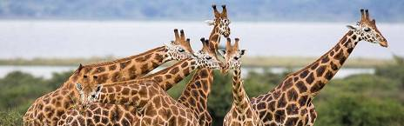

Day 2

Start your journey to Murchison Falls National Park
After a morning Breakfast, your driver will pick you up from Entebbe and start a road trip to Murchison Falls National Park via Zziwa Rhino Sanctuary where you'll have the opportunity to track the Rhinos.
A Local ranger guide will lead you on foot to an up-close encounter with the Rhinos and after proceed to Masindi for a hot lunch. Later continue to Murchison falls arriving in the late afternoon with a visit at the top of the falls for a remarkable sight of the Nile crushing through a narrow gorge just 7m wide before plunging 43m deep into the devil’s cauldron. Relax at your booked lodge as you prepare for the next day's immersion.
Main Destination:
Murchison Falls National Park
Best Time To Visit December to February (Easier to spot animals)
High Season June to September (Peak time for Uganda)
Best Weather June and July (Less rain and lower temperatures)
Accommodation:
Pakuba Safari Lodge
- Mid-range lodge located inside Murchison Falls NP







+4Photos

Meals & Drinks:
- All meals included
- Non-alcoholic drinks
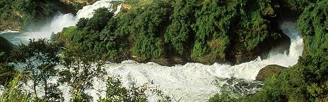

Day 3

Game drives, Top view of the falls
Arise very early in the morning, have your breakfast and go for a morning game drive on the Northern bank of the Nile to a diverse destination which offers a unique combination of wildlife, birdwatching and stunning landscapes.
Here you'll spot a wide variety of animals including Elephants, Leopards, Cape Buffaloes, Oribi, Bushbuck, Roth-child’s giraffe among others and after return to your lodge for lunch.
After lunch, enjoy an evening boat cruise along the river upstream the calm Victoria Nile to the base of the falls taking in the stunning views and capturing moments, marvel at Crocodiles, yawning Hippos and over 16km stretch, you may see Waterbucks, Uganda Kob, Elephants and Bird species like Pelican bee-eater, Kingfishers, Goliath heron, Hornbills, Egyptian goose and the rare Shoebill stork.
You may choose to continue to he top of the falls for an amazing view.
Main Destination:
Murchison Falls National Park
Accommodation:
Pakuba Safari Lodge
- Mid-range lodge located inside Murchison Falls NP
Meals & Drinks:
- All meals included
- Non-alcoholic drinks
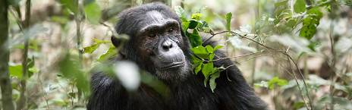

Day 4

Transfer to Kibale Forest National Park
Begin your journey with a Breakfast at your accommodation, Set off on a scenic drive towards Kibale Forest National Park. As you travel south, gaze out the window to take Uganda's stunning beauty, including rolling hills, lush farmlands, and charming local villages.
Midway through your drive, stop in the bustling town of Hoima for a delicious lunch sample local Ugandan dishes at a cozy eatery, experience the local culture and market vibes.
After lunch, continue your journey towards Kibale Forest. The road winds through beautiful scenery giving you opportunities to spot various bird species and perhaps even some local wildlife As you approach the park, the landscape transforms into dense tropical rainforest, hinting at the incredible biodiversity that awaits.
Main Destination:
Kibale National Park (Chimps)
Best Time To VisitJanuary to February and June to July (Chimp trekking is easiest)
High SeasonJune to September (Peak time for Uganda)
Best WeatherJanuary to February and June to July (Least rain)
Accommodation:
Turaco Treetops Lodge
- Mid-range lodge bordering Kibale NP (Chimps) without fences







+18Photos

Meals & Drinks:
- All meals included
- Non-alcoholic drinks

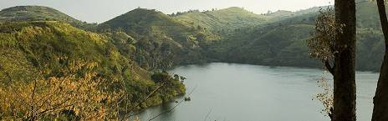

Day 5

Chimpanzee Trekking
At 6:30am, go for your breakfast and immediately transfer to the park Headquarters at Kanyanchu
for a briefing by the park ranger. Guided by experienced trackers, you'll navigate through lush forests to observe and learn about these intelligent and social animals ( our closest relatives).
Hearing the calls of chimps and seeing them swing through the trees is one-of-a kind experience.
After the chimp trek return to the lodge for lunch as you prepare to go for an evening nature walk in the Bigodi wetland expect to see some primates including Red-tailed monkeys, Grey-cheeked mangabey, black and white colobus monkeys and a plethora of birds including the great blue turaco.
Main Destination:
Kibale National Park (Chimps)
Accommodation:
Turaco Treetops Lodge
- Mid-range lodge bordering Kibale NP (Chimps) without fences
Meals & Drinks:
- All meals included
- Non-alcoholic drinks

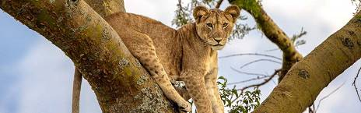

Day 6

Transfer to Queen Elizabeth National Park
Welcome to Queen Elizabeth National Park which is located in Southwestern Uganda, and is one of the the most celebrated National Parks. The Park is renowned for its stunning landscapes, open savannahs, crater lakes and rich biodiversity. On your first day here, start by having a delicious meal at your booked lodge while enjoying the scenic view of the park.
Main Destination:
Queen Elizabeth National Park
Best Time To VisitJanuary to February and June to July (Dry seasons)
High SeasonJune to September (Peak time for Uganda)
Best WeatherJune to July and January to February (Less rainfall)
Accommodation:
Irungu Forest Safari Lodge
- Mid-range lodge located just outside Queen Elizabeth NP

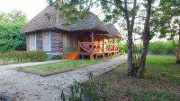
+6Photos

Meals & Drinks:
- All meals included
- Non-alcoholic drinks

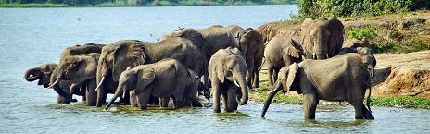

Day 7

Game Drives, Visit Kazinga Channel
On the second day to Queen Elizabeth National Park, Start with a delicious breakfast, next go for a game drive in the Kasenyi plains that may lead you to Ugandan kob, Defassa waterbuck, Elephants, topi, Bushbuck and many more.
Late afternoon, visit Kazinga channel for a soothing boat ride and witness a variety of bird species such as Yellow crown, Malachite kingfishers, Pink backed pelicans, Papyrus gonolek and some crocodiles, Buffaloes, Hippos.
Main Destination:
Queen Elizabeth National Park
Accommodation:
Irungu Forest Safari Lodge
- Mid-range lodge located just outside Queen Elizabeth NP
Meals & Drinks:
- All meals included
- Non-alcoholic drinks
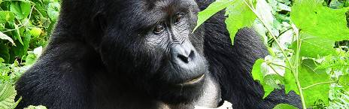

Day 8

Transfer to Bwindi Impenetrable Forest
After a heavy Breakfast, you will depart for Bwindi Impenetrable National Park- a home to half of
the endangered Mountain Gorillas in the world.
It's a scenic drive with an en route game-drive in Ishasha Plains where you'll have the chance to spot Tree-climbing lions sheltering from the fierce Rift valley sun on the trees.
Arrive in the evening and wrap up your day with a tasty Dinner at your booked lodge. Its a day filled with Wildlife, Adventure and Nature.
Main Destination:
Bwindi Impenetrable National Park (Gorillas)
Best Time To VisitJune to August and December to February (Gorilla trekking is easiest)
High SeasonJune to September (Gorilla permits are scarce)
Best WeatherJune to July and December to February (Less rainfall)
Accommodation:
Bakiga Lodge
- Budget lodge located just outside Bwindi Impenetrable NP (Gorillas)



Meals & Drinks:
- All meals included
- Non-alcoholic drinks

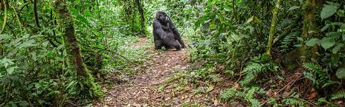

Day 9

Gorilla Trekking, Transfer to Lake Bunyonyi
After an early breakfast, depart to the starting point for a briefing about your gorilla trekking adventure. From there you will be led by the experienced gorilla trackers through the terrain and thick vegetation which spices up the experience.
Along the way you may encounter other primates including Black-faced vervet monkeys, L’Hoest monkeys among others. The activity takes 2-6 hours depending on the movement of these apes. Once you encounter the Gorillas, you'll have a magical hour with them for a rare glimpse into the lives of these endangered species.
After the trek, unwind by heading to the serene Lake Bunyonyi. Known for its deep waters and numerous islands, provides a tranquil setting for activities such as canoeing, swimming and Birding.
Main Destination:
Bwindi Impenetrable National Park (Gorillas)
Accommodation:
Bunyonyi Safaris Resort
- Mid-range resort located at Lake Bunyonyi



Meals & Drinks:
- All meals included
- Non-alcoholic drinks



Day 10

Return to Entebbe, Departure
Start your day with a cup of coffee, after a delicious breakfast get yourself ready for a road trip to Kampala with a stopover at the Equator where you'll have lunch, and to experience the 2 Hemispheres at the same time.
After fuelling up continue to Kampala and we hope you’ve had the most amazing adventure trip exploring the beauty of nature.
Travel safely back to your home country.
Main Destination:
Entebbe (City)
Accommodation:
No accommodation (End of tour)
Meals & Drinks:
- Breakfast & lunch (Dinner not included)
- Non-alcoholic drinks

End of tour

Additional accommodation can be arranged for an extra cost.
- You'll be dropped off at the airport.

Rates

Important to Know
- Rates are per person and exclude the international flight from/to your home country.
- This tour is unavailable for children.

Rates Per Person
Start dates | Solo1 room | 2+ people Sharing rooms
Jan 1, 2025 - Dec 31, 2025 | $4,950 | $3,993
Jan 1, 2026 - Dec 31, 2026 | $4,950 | $3,993

Included
- Park fees(For non-residents)
- Gorilla permits(One per person, non-resident)
- Chimp permits(One per person, non-resident)
- All activities(Unless labeled as optional)
- All accommodation(Unless listed as upgrade)
A professional driver/guide
- All transportation(Unless labeled as optional)
- All Taxes/VAT
- Roundtrip airport transfer
- Meals(As specified in the day-by-day section)
- Drinks(As specified in the day-by-day section)

Excluded
- International flights(From/to home)
- Additional accommodation before and at the end of the tour
- Tips(Tipping guideline US$10.00 pp per day)
- Personal items(Souvenirs, travel insurance, visa fees, etc.)
- Government imposed increase of taxes and/or park fees
- Some meals(As specified in the day-by-day section)

